To: Department of Student Affairs
Name of Society/Club: _YOGA CLUB SUNGAI LONG____________________________________ Code No.: __________________ Date: __7__/_AGU_/_2026_

I have pleasure in submitting a list of our office bearers for the term of office effective from _____/_____/_____ to _____/_____/_____ as required by your department. They were elected during our Annual General Meeting held on _____/_____/_____.
Designation | Name | Student ID. | Course | Year | Email Address | Contact No. | Signature
Chairperson | LIM SAI KEAT | 25UEB04365 | SE | Y1S3 | Susie.limsk@1utar.my | +60183927135 | 
Vice Chairperson
Secretary | BONG XIAO THUNG | 26UEB01640 | SE | Y1S1 | bongxiaothung@1utar.my | 01129993353
Assistant Secretary | LIM WEI QI | 25UKB01853 | FT | Y1S1 | weiqi07@1utar.my | 0102209866 | 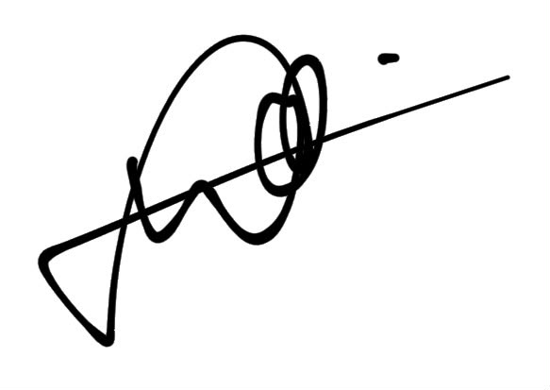
Treasurer | TARVEEN KAUR A/P JURA SINGH | 24UMB05678 | NS |  | tarveen01@1utar.my | 01123378072
Assistant Treasurer
Committee Member | Iviana Chong Shu Ping | 24UMB02969 | PS | Y2S1 | ivianachong060612@1utar.my | 017-9985463 | 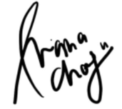
Committee Member | Justin Loo Jun Han | 24UEB00529 | SE | Y1S2 | pandora@1utar.my | 012-7102078 | 
Committee Member | POH KAI XIN | 25UMB01415 | AT | Y2S1 | pohkaixin0317@1utar.my | 014-9818350
Committee Member | Tan Xin Le | 22UKB06042 | AT | Y3S3 | xinletan@1utar.my | 012-3022723 | 
Committee Member
Auditor | Vivian Tang Yen Ai | 21UKB04664 | AT |  | vivian.tang233@1utar.my | 0163013777 | 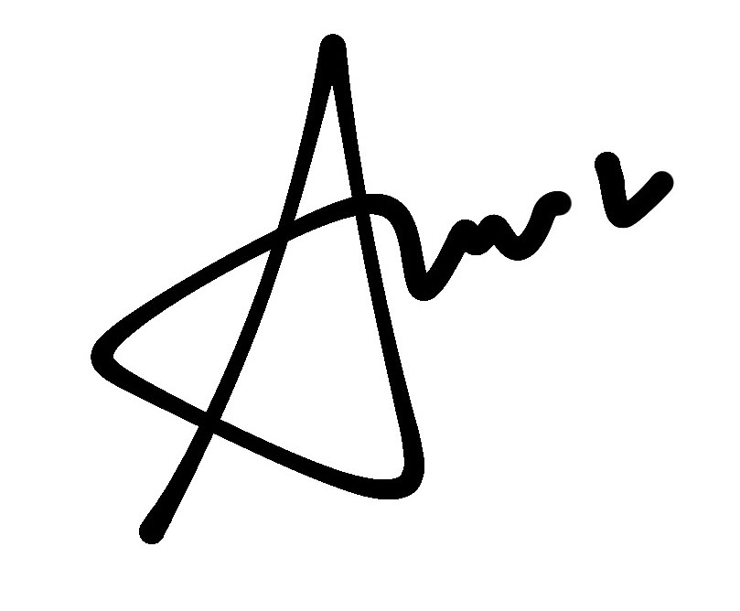
Auditor | PONG EN NI | 22UEB07210 | QS |  | anny1216@1utar.my | 01137596228 | 

_______________________________________________ _________________________________________________
Signature Signature

Name of Adviser: ________________________________ Name of Honorary Secretary: ___________________________________

